Vehicle Handover and Return Form  Company vehicle (custody) · United Arab Emirates | Company
 | Form no.
 | Date

A Employee (driver)

Employee name |  | Employee ID
Department / job title |  | Mobile number
Emirates ID number |  | Driving licence number
Licence issued in (emirate) |  | Licence expiry date
Approved by (manager) |  | Expected return date
Type of use | ☐ Assigned vehicle ☐ Pool / shared vehicle ☐ Temporary replacement ☐ Other: ______________

B Vehicle

Make and model |  | Year and colour
Plate: emirate |  | Plate: code and number
VIN / chassis number |  | Mulkiya (registration) expiry
Insurance policy no. / expiry |  | Fuel card number
Salik tag number (Dubai) |  | Darb (Abu Dhabi) | ☐ Registered in company account ☐ N/A
Tracker / telematics | ☐ Installed ☐ None | Telematics unit ID

C Readings at handover and return

Item | At handover (to employee) | At return (to company)
Date and time
Location / parking spot
Odometer (km)
Fuel level (or EV battery) | ______ % ☐ E ☐ ¼ ☐ ½ ☐ ¾ ☐ F | ______ % ☐ E ☐ ¼ ☐ ½ ☐ ¾ ☐ F
Dashboard warning lights | ☐ None ☐ Yes: ________________ | ☐ None ☐ Yes: ________________
Cleanliness (inside / outside) | ☐ Clean ☐ Needs cleaning | ☐ Clean ☐ Needs cleaning
Distance driven (km) = return reading − handover reading

D Equipment and documents

Item | Handover | Return |  | Item | Handover | Return
Keys / key fob (quantity: ___) | ☐ | ☐ |  | Spare tyre or repair kit | ☐ | ☐
Mulkiya (registration card) | ☐ | ☐ |  | Jack and wheel spanner | ☐ | ☐
Insurance certificate | ☐ | ☐ |  | Warning triangle | ☐ | ☐
Salik tag on windscreen | ☐ | ☐ |  | Fire extinguisher | ☐ | ☐
Fuel card | ☐ | ☐ |  | First aid kit | ☐ | ☐
Parking / access card | ☐ | ☐ |  | Floor mats | ☐ | ☐
Phone holder / charging cable | ☐ | ☐ |  | Other: ________________ | ☐ | ☐

E Damage diagram

At handover | At return
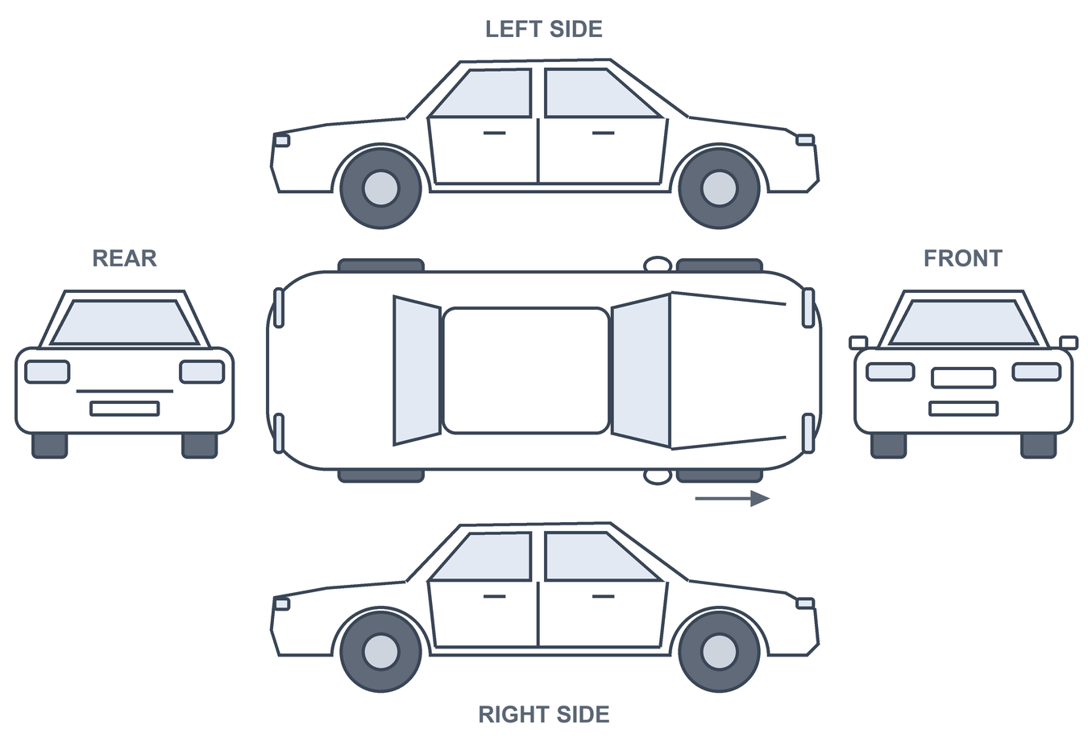
Mark each damage on the diagram and write its code: S = scratch · D = dent · C = chip or crack (glass) · B = broken part · M = missing part. Take a photo of every mark.
No. | Location / part and remarks | Code | Size (cm) | Photo no. | Found at
1 |  |  |  |  | ☐ Handover ☐ Return
2 |  |  |  |  | ☐ Handover ☐ Return
3 |  |  |  |  | ☐ Handover ☐ Return
4 |  |  |  |  | ☐ Handover ☐ Return

F Photo checklist (time-stamped photos)

Photo | Handover | Return |  | Photo | Handover | Return
Front | ☐ | ☐ |  | Dashboard: odometer and fuel | ☐ | ☐
Rear | ☐ | ☐ |  | Windscreen with Salik tag | ☐ | ☐
Left side | ☐ | ☐ |  | Front seats | ☐ | ☐
Right side | ☐ | ☐ |  | Rear seats | ☐ | ☐
Front-left corner | ☐ | ☐ |  | Boot / trunk | ☐ | ☐
Front-right corner | ☐ | ☐ |  | Tyres and wheels | ☐ | ☐
Rear-left corner | ☐ | ☐ |  | Close-up of every damage | ☐ | ☐
Rear-right corner | ☐ | ☐ |  | Front and rear number plates | ☐ | ☐

Photos stored in | ☐ App with automatic time stamp ☐ Company phone / shared folder: ____________________

G Declarations and signatures

At handover: I, the employee signing below, confirm that I received the vehicle with the condition, equipment and readings recorded above, and that I will use it according to the company vehicle policy.
 | Name | Position | Signature | Date and time
Handed over by (company)
Received by (employee)
At return: the vehicle was returned with the condition recorded above. Traffic fines, Salik/Darb tolls and damage during the custody period are handled per company policy and applicable UAE law.
 | Name | Position | Signature | Date and time
Returned by (employee)
Received by (company)
This form is an internal company record. It does not replace the vehicle registration (Mulkiya), the insurance documents or a police report after an accident.

